Task 5

1. Chat GPT

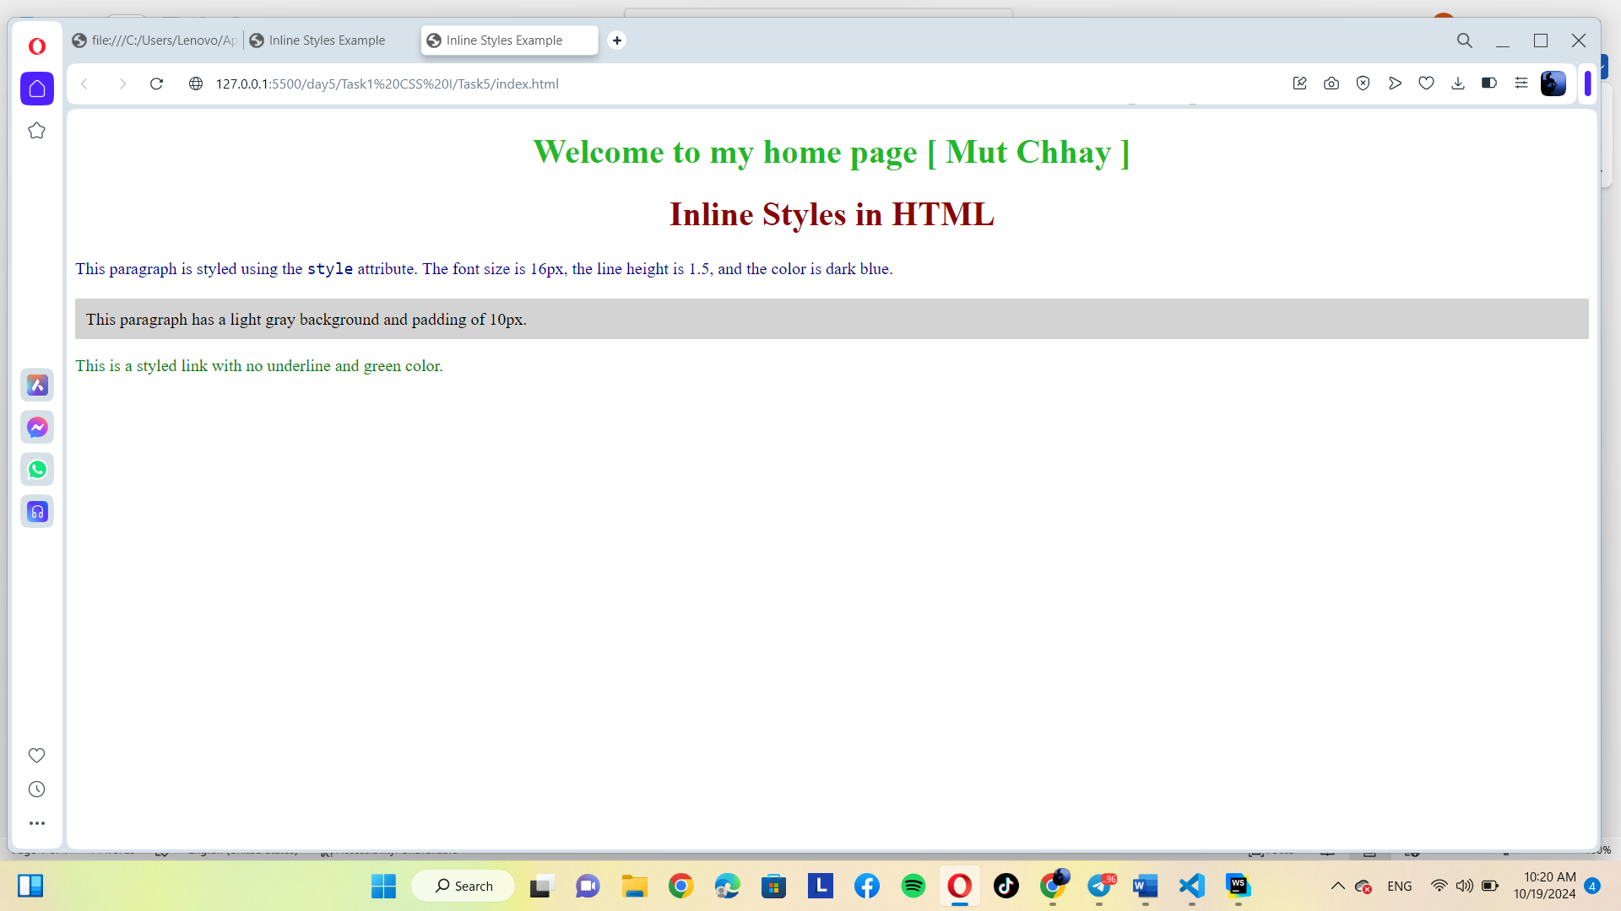

2. Gemini

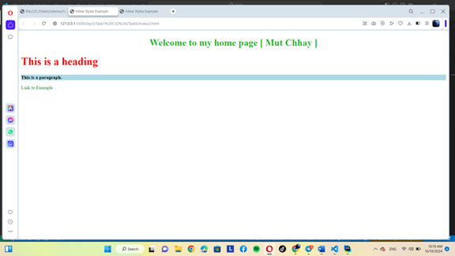

Result is the same both follow the prompt